ABERYSTWYTH PRINTMAKERS MOVING FUND RAISING RAFFLE 2020
Sadly, due to Covid 19 AP has lost almost all of its income from workshop use and classes. As planned, AP will be moving this year whilst the Old College is being renovated. This comes with some extra costs, in particular moving the beautiful presses safely requires hiring an expert. AP has created two appeals to help raise funds to fund the move and keep AP going until the workshop can reopen again. The first is a sale of members work. 50% of each print sale made through AP will be donated by the artist towards keeping AP operational and the expenses of moving. See https://www.aberystwythprintmakers.org.uk/print-gallery-shop to view the work and make purchases. The other fundraising opportunity is a raffle. We are raffling six prints from the print club and a book on Plate Lithography, authored by AP’s chairperson, Paul Croft. The six winners of the print will be able to select the print they want (so if you have already bought a print, you won’t have to receive the same one). The seventh winner will receive the book. The raffle will be drawn on 30th August 2020. Tickets are £5 each or 3 for £10. You can help by buying tickets and also by selling them to your friends and family. Because of the current physical limitations please find attached raffle tickets to sell via email. The purchaser can fill out the ticket, make a payment via paypal (aberystwythprintmakers@gmail.com) and send the ticket to aberystwythprintmakers@gmail.com

The PRINT CLUB PRINTS:
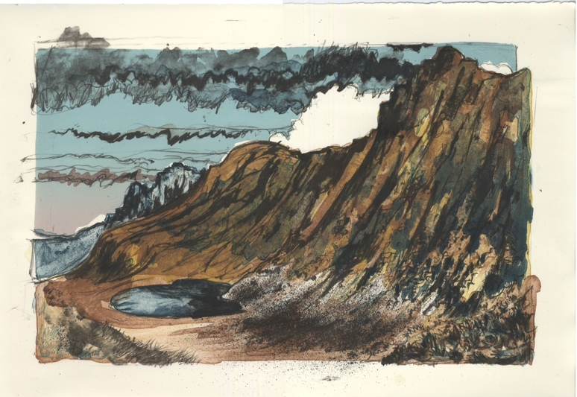 | 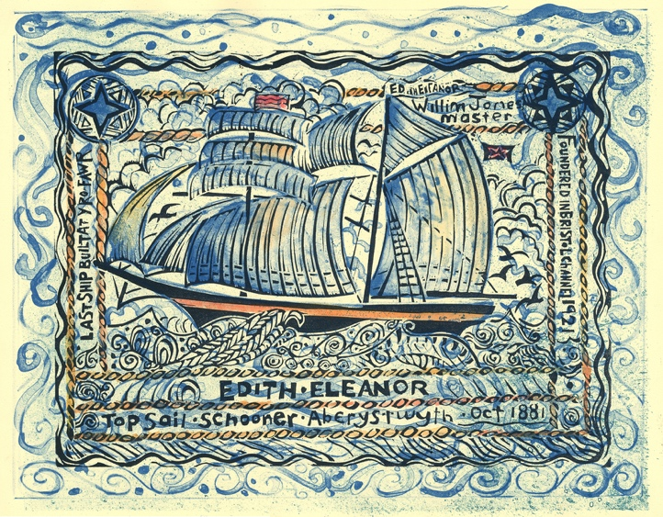
2014 Ian Phillips  Title: Creiglyn  Media: 5-run lithograph  Paper: Hahnemühle  Size: 420mm x 610mm  Edition: 30 | 2016 Stuart Evans  Title: The Edith Eleanor  Media: 2-run Lithograph & Linocut  Paper: Rives Cream / Grey  Size: 382mm x 545mm  Edition: 30 (15/15)
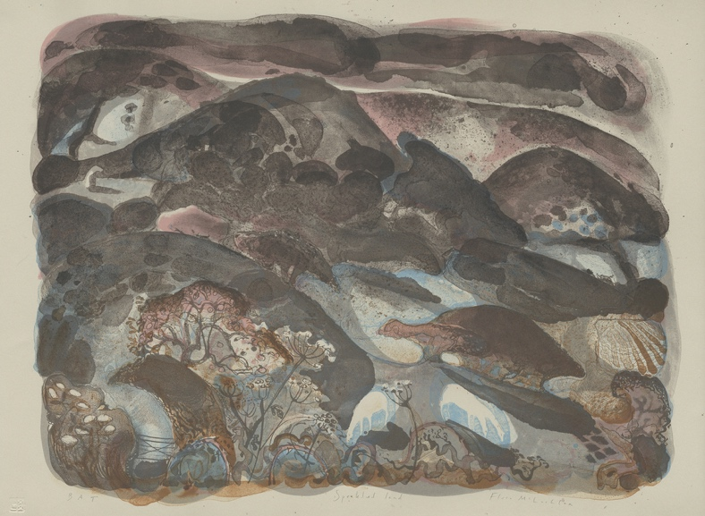 | 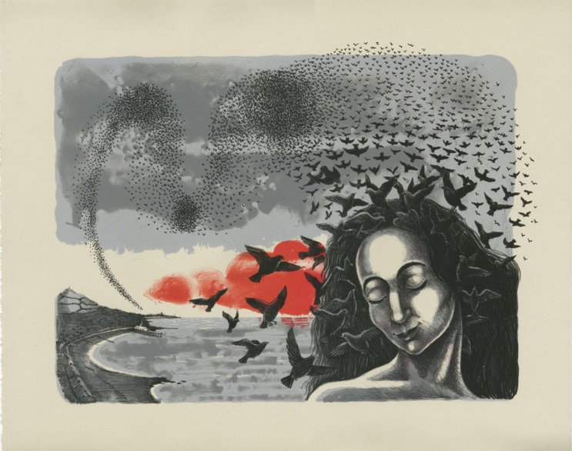
2017 Flora McLachlan RE  Title: Speckled Land  Media: 5-run Lithograph  Paper: Rives Grey  Size: 380mm x 535mm  Edition: 30 | 2018 Gini wade  Title: Rhiannon’s Dream  Media: 4-run Lithograph  Paper: Rives Grey / Somerset Grey  Size: 430mm x 540mm  Edition: 30 (15/15)

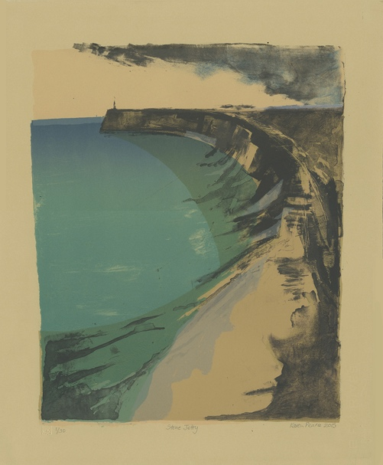 | 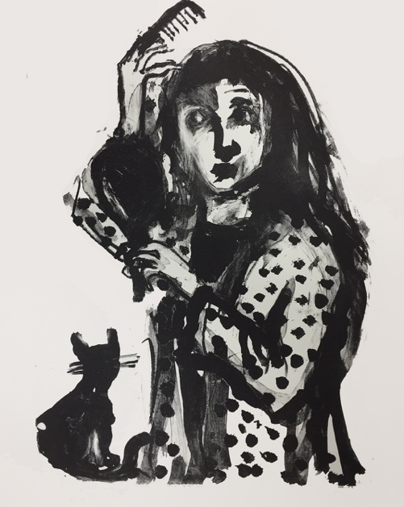 | 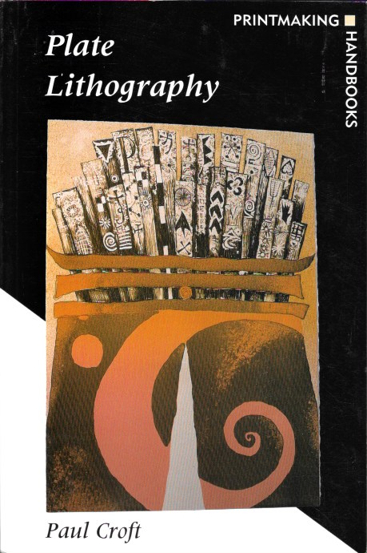
2015 Karen Pearce  Title: Stone Jetty  Media: 6-run lithograph  Paper: Rives Tan / Cream / Grey  Size: 530mm x 440mm  Edition: 30 (10/10/10) | 2019 Shani Rhys James MBE  Title: Combing Her Hair  Media: 1-run Lithograph  Paper: Hahnemühle  Size: 320mm x 260mm  Edition: 25 | 2003 Plate Lithography (Signed Copy)  Author: Paul Croft  Published by A&C Black as part of the A&C Black Series of Printmaking Handbooks  Pp 160pages  Covers all aspects of plate lithography including Aluminium and Zinc Plate, Photoplate and Waterless Lithography techniques. No longer available except via second hand dealers (average price £55-£400)

ABERYSTWYTH PRINTMAKERS MOVING FUND RAISING RAFFLE  Drawn on August 30, 2020  Name:______________________  Address:____________________  Phone:_____________________  $5 each or 3 for £10 | ABERYSTWYTH PRINTMAKERS MOVING FUND RAISING RAFFLE  Drawn on August 30, 2020  Seven prizes:  Prize one to six: Choice of print from AP Print Club  Ian Phillips, Karen Pearce, Shani Rhys James, Flora McLachlan RE, Gini Wade, Stuart Evans  Prize Seven: Book – Plate Lithography by Paul Croft  $5 each or 3 for £10
ABERYSTWYTH PRINTMAKERS MOVING FUND RAISING RAFFLE  Drawn on August 30, 2020  Name:______________________  Address:____________________  Phone:_____________________  $5 each or 3 for £10 | ABERYSTWYTH PRINTMAKERS MOVING FUND RAISING RAFFLE  Drawn on August 30, 2020  Seven prizes:  Prize one to six: Choice of print from AP Print Club  Ian Phillips, Karen Pearce, Shani Rhys James, Flora McLachlan RE, Gini Wade, Stuart Evans  Prize Seven: Book – Plate Lithography by Paul Croft  $5 each or 3 for £10
ABERYSTWYTH PRINTMAKERS MOVING FUND RAISING RAFFLE  Drawn on August 30, 2020  Name:______________________  Address:____________________  Phone:_____________________  $5 each or 3 for £10 | ABERYSTWYTH PRINTMAKERS MOVING FUND RAISING RAFFLE  Drawn on August 30, 2020  Seven prizes:  Prize one to six: Choice of print from AP Print Club  Ian Phillips, Karen Pearce, Shani Rhys James, Flora McLachlan RE, Gini Wade, Stuart Evans  Prize Seven: Book – Plate Lithography by Paul Croft  $5 each or 3 for £10
ABERYSTWYTH PRINTMAKERS MOVING FUND RAISING RAFFLE  Drawn on August 30, 2020  Name:______________________  Address:____________________  Phone:_____________________  $5 each or 3 for £10 | ABERYSTWYTH PRINTMAKERS MOVING FUND RAISING RAFFLE  Drawn on August 30, 2020  Seven prizes:  Prize one to six: Choice of print from AP Print Club  Ian Phillips, Karen Pearce, Shani Rhys James, Flora McLachlan RE, Gini Wade, Stuart Evans  Prize Seven: Book – Plate Lithography by Paul Croft  $5 each or 3 for £10
ABERYSTWYTH PRINTMAKERS MOVING FUND RAISING RAFFLE  Drawn on August 30, 2020  Name:______________________  Address:____________________  Phone:_____________________  $5 each or 3 for £10 | ABERYSTWYTH PRINTMAKERS MOVING FUND RAISING RAFFLE  Drawn on August 30, 2020  Seven prizes:  Prize one to six: Choice of print from AP Print Club  Ian Phillips, Karen Pearce, Shani Rhys James, Flora McLachlan RE, Gini Wade, Stuart Evans  Prize Seven: Book – Plate Lithography by Paul Croft  $5 each or 3 for £10
ABERYSTWYTH PRINTMAKERS MOVING FUND RAISING RAFFLE  Drawn on August 30, 2020  Name:______________________  Address:____________________  Phone:_____________________  $5 each or 3 for £10 | ABERYSTWYTH PRINTMAKERS MOVING FUND RAISING RAFFLE  Drawn on August 30, 2020  Seven prizes:  Prize one to six: Choice of print from AP Print Club  Ian Phillips, Karen Pearce, Shani Rhys James, Flora McLachlan RE, Gini Wade, Stuart Evans  Prize Seven: Book – Plate Lithography by Paul Croft  $5 each or 3 for £10
ABERYSTWYTH PRINTMAKERS MOVING FUND RAISING RAFFLE  Drawn on August 30, 2020  Name:______________________  Address:____________________  Phone:_____________________  $5 each or 3 for £10 | ABERYSTWYTH PRINTMAKERS MOVING FUND RAISING RAFFLE  Drawn on August 30, 2020  Seven prizes:  Prize one to six: Choice of print from AP Print Club  Ian Phillips, Karen Pearce, Shani Rhys James, Flora McLachlan RE, Gini Wade, Stuart Evans  Prize Seven: Book – Plate Lithography by Paul Croft  $5 each or 3 for £10
ABERYSTWYTH PRINTMAKERS MOVING FUND RAISING RAFFLE  Drawn on August 30, 2020  Name:______________________  Address:____________________  Phone:_____________________  $5 each or 3 for £10 | ABERYSTWYTH PRINTMAKERS MOVING FUND RAISING RAFFLE  Drawn on August 30, 2020  Seven prizes:  Prize one to six: Choice of print from AP Print Club  Ian Phillips, Karen Pearce, Shani Rhys James, Flora McLachlan RE, Gini Wade, Stuart Evans  Prize Seven: Book – Plate Lithography by Paul Croft  $5 each or 3 for £10

